The term "instability strip" refers to a region on a Hertzsprung-Russell diagram where many common variable stars lie. It extends from around the main sequence turn off up through the G and K class supergiant region (see figure).

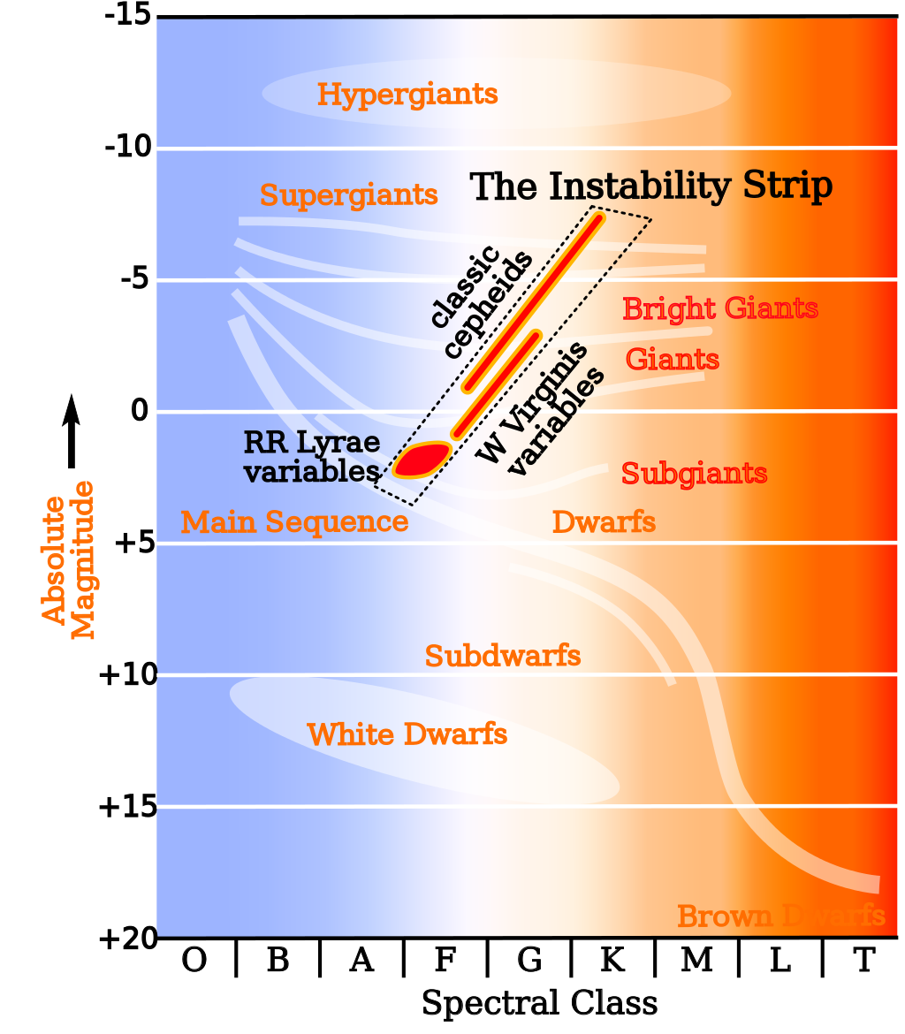

On the bluer, smaller end sit the RR Lyrae giant variables, followed by Delta Scuti variables (dwarf variables), then Cepheids and RV Tauri variables in the supergiants. There are a myriad of other types of variables here, as seen in the following tree diagram from Eyer and Mowlavi (2008). These are distinguished by size, stellar class, and mechanism for variation, but we're mostly concerned with how to remove them from the region right around the MSTO where they could be confused for blue stragglers.

This means that our biggest problem will probably be the RR Lyrae type variables, since they hang right around the MSTO. There are also blue stragglers which themselves vary--these are called SX Phoenicis variables, and their period of variation is on the order of an hour or two. We need to be careful not to accidentally dump them along with the other variables when we start filtering. RR Lyrae variables typically change on a timescale a little less than a day's length, sometimes down to a few hours, but still above VBS territory. We should, then, be able to separate them based on period.

